Arshdeep Kaur(A 01)

200465607

Northwind Database

Part A-

High Level Data Model

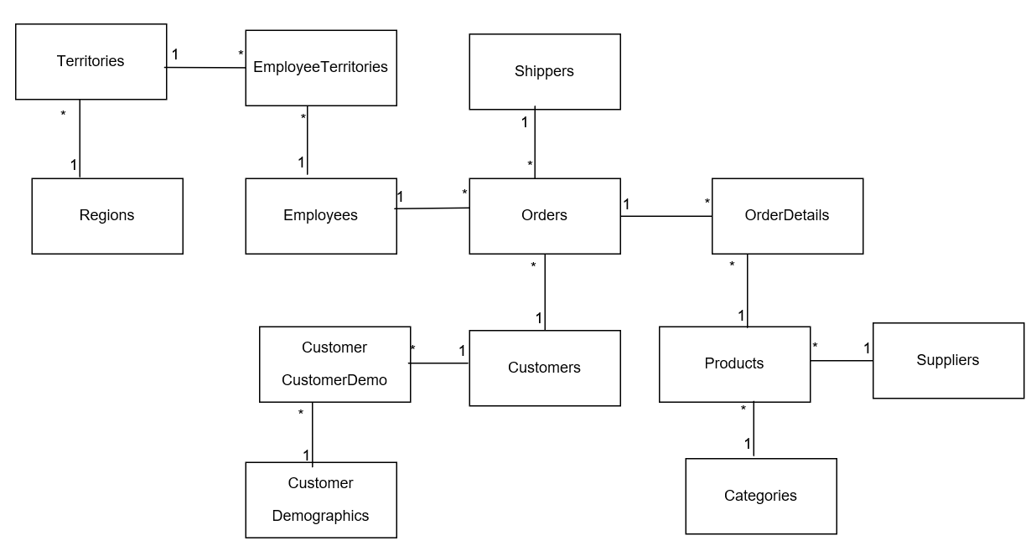

Data Dictionary

|  |
| --- |
| Employees |
| <<PK>> EmployeeID: Number {start=1, increment=1}  LastName:Unicode string {size=20}  FirstName:UnicodeString {size=10}  Title:Unicode string{size=30}  TitleOfCountry:Unicode string {size=20}  BirthDate: Date {BirthDate < Current Date}  HireDate:Date  Address:Unicode string{size=60}  City:Unicode string{size=15}  Region: Unicode string{size=15}  Postal Code: Unicode string{size=10}  Country: Unicode string{size=15}  HomePhone:Unicode String{size=24}  Extension: Unicode string{size=4}  Photos: Image  Notes: Unicode string{size=32}  ReportsTo: Number{ReportsTo=EmployeeID}  PhotoPath:Unicode string{size=255} |

|  |
| --- |
| Categories |
| <<PK>> CategoryID: Number{start=1,Increment=1}  CategoryName:Unicode string{size=15}  Description:Unicode string{size=32}  Picture: Bitmap |

|  |
| --- |
| Customers |
| <<PK>> CustomerID: Unicode string{size=5}  ComapnyName: Unicode string{size=40}  ContactName:Unicode string{size=30}  ContactTitle: Unicode string{size=30}  Address: Unicode string{size=60}  City: Unicode string{size=15}  Region: Unicode string{size=15}  PostalCode: Unicode string{size=10}  Country: Unicode string {size=15} |

|  |
| --- |
| Shippers |
| <<PK>> ShipperID: Number{start=1, increment=1}  CompanyName: Unicode string{size=40}  Phone: Unicode string{size=24} |

|  |
| --- |
| Suppliers |
| <<PK>>SupplierID: Number{start=1, increment=1}  CompanyName: Unicode string {size=40}  ContactName: Unicode string{size=30}  ContactTitle:Unicode string{size30}  Address: Unicode string{size=60}  City:Unicode string{size=15}  Region: Unicode string{size=15}  Postal Code:Unicode String{size=10}  Country:Unicode string{size=15}  Phone: Unicode string{size=24}  Fax: Unicode string {size=24}  HomePage: Unicode String{size=32} |

|  |
| --- |
| Orders |
| <<PK>>OrderID:Number{start=1, increment=1}  <<FK>>CustomerID: Unicode string {size=5, reference= Customers}  <<FK>>EmployeeID: Number {reference = Employees}  OrderDate: Date  RequiredDate: Date  ShippedDate: Date  <<FK>>ShipVia: Number {reference= Shippers}  Freight: Currency=’0’  ShipName: Unicode string{size=40}  ShipAddress: Unicode string{size=60}  ShipCity:Unicode string{size=15}  ShipRegion: Unicode string{size=15}  ShipPostalCode: Unicode string{size=10}  ShipCountry: Unicode string{size=15} |

|  |
| --- |
| Products |
| <<PK>>ProductID:Number{start=1, increment=1}  ProductName: Unicode string{size=40}  <<FK>>SupplierID: Number{reference=Suppliers}  <<FK>>CategoryID:Number{reference=Categories}  QuantityPerUnit: Unicode string{size=20}  UnitPrice: Currency =’0’{UnitPrice >=0}  UnitsInStock: Number=’0’{UnitsInStock>=0}  UnitsOnOrder:Number=’0’{UnitsOnOrder>=0}  ReorderLevel:Number=’0’{ReorderLevel>=0}  Discontinued: Number=’0’ |

|  |
| --- |
| Order Details |
| <<PK>><<FK>>OrderID:Number{key=PK, order=1, reference=Orders}  <<PK>><<FK>>ProductID:Number{key=PK, order=2, reference=Products}  UnitPrice:Currency =’0’  Quantity:Number = ‘0’  Discount: Number = ‘0’ |

|  |
| --- |
| CustomerCustomerDemo |
| <<PK>><<FK>>CustomerID: Unicode string {size=5, key=PK, order=1, key=FK, reference=Customers}  <<PK>><<FK>>CustomerTypeID: Unicode string {size=10, key=PK, order=2, key=FK, reference = CustomerDemographics} |

|  |
| --- |
| CustomerDemographics |
| <<PK>>CustomerTypeID: Unicode string{size=10}  CustomerDescription: Unicode string{size=32} |

|  |
| --- |
| Region |
| <<PK>>RegionID: Number  RegionDescription: Unicode string{size=50} |

|  |
| --- |
| Territories |
| <<PK>>TerritoryID:Unicode string{size=20}  TerritoryDescription: Unicode String{size=50}  <<FK>>RegionID: Number{reference=Region} |

|  |
| --- |
| EmployeeTerritories |
| <<PK>><<FK>>EmployeeID: Number{key=PK, order=1, reference=Employees}  <<PK>><<FK>>TerritoryID: Unicode string{size=20, key=PK, order=2, reference=Territories} |

Part- B

Data Mart

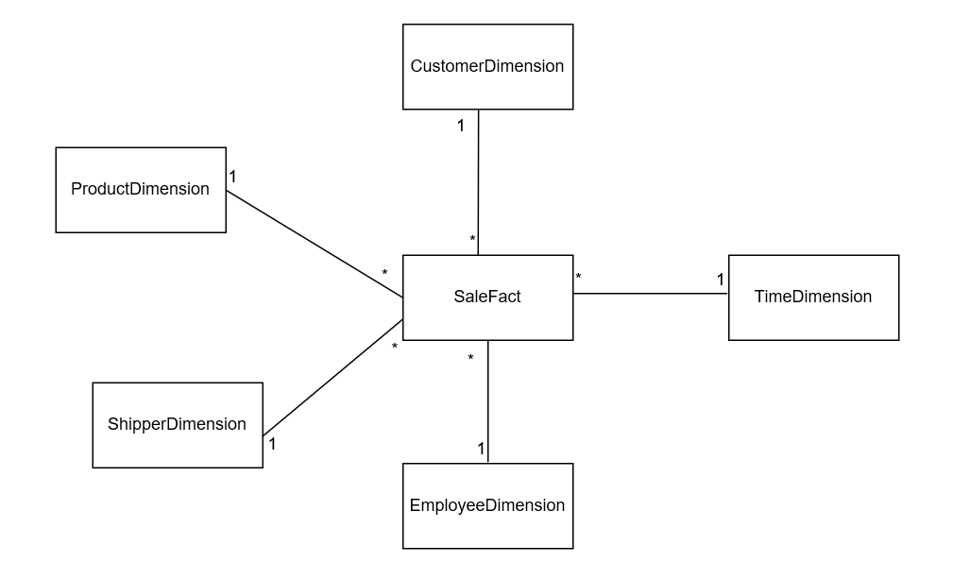

Data Dictionary entries for Dimension Table and Fact Table:_-

|  |
| --- |
| Customer Dimension |
| <<PK>> CustomerKey: Number {start=1, increment = 1}  CompanyName: UnicodeString {size=40}  CustomerID: UnicodeString{size=5}  ContactName: UnicodeString{size=30}  ContactTitle:UnicodeString{size=30}  Address: UnicodeString{size=60}  City: UnicodeString{size=15}  Region: UnicodeString{size=16}  PostalCode:UnicodeString{size=10}  Country: UnicodeString{size=15}  Phone:UnicodeString{size=24}  Fax:UnicodeString{size=24} |

|  |
| --- |
| EmployeeDimension |
| <<PK>> EmployeeKey: Number {start=1, increment =1}  EmployeeName: UnicodeString{size=35}  EmployeeID: Number {EmployeeID >=1}  HireDate: Date |

|  |
| --- |
| ProductDimension |
| <<PK>> ProductKey: Number{start=1, increment =1}  ProductName: UnicodeString{size=40}  ProductID: Number{ProductID >=1}  SupplierName:UnicodeString{size=40}  CategoryName:UnicodeString{size=15} |

|  |
| --- |
| ShipperDimension |
| <<PK>> ShipperKey: Number{start=1, increment=1}  ShipperName: UnicodeString{size=40}  ShipperID: Number{ShipperID> =1} |

|  |
| --- |
| TimeDimension |
| <<PK>> TimeKey: Number{start=1, increment =1}  TheDate: Date  DayOfWeek: Number  DayOfWeekName: UnicodeString  Month: Number  MonthName:UnicodeString  Year: Number  Quarter: Number  DayOfYear: Number  WeekDay: UnicodeString{size=1, Weekday =’Y’ or Weekday =’N’}  WeekOfYear: Number |

|  |
| --- |
| SaleFact |
| <<PK>><<FK>> CustomerKey: Number{key =PK, order=1, reference = CustomerDimension}  <<PK>><<FK>>EmployeeKey: Number{key= pk, order =2, reference=EmployeeDimension}  <<Pk>><<FK>>ProductKey:Number{key=PK, order =3, reference =ProductDimension}  <<PK>><<FK>>ShipperKey:Number{key=PK, order=4, reference=ShipperDimension}  <<PK>><<FK>>TimeKey:Number{key=PK, order=5, reference=TimeDimension}  LineItemQuantity:Number  LineItemDiscount:Number  LineItemFreight:Currency  LineItemTotal:Currency |

Transact- SQL For Data Mart

Create table CustomerDimension( CustomerKey int Primary Key NONCLUSTERED IDENTITY(1,1) NOT NULL,

CompanyName nvarchar(40) NOT NULL,

CustomerID nvarchar(5) NOT NULL,

ContactName nvarchar(30),

ContactTitle nvarchar(30),

Address nvarchar(60),

City nvarchar(15),

Region nvarchar(15),

PostalCode nvarchar(10),

Country nvarchar(15),

Phone nvarchar(24),

Fax nvarchar(24))

Create table EmployeeDimension( EmployeeKey int Primary Key NONCLUSTERED IDENTITY(1,1) NOT NULL,

EmployeeName nvarchar(35) NOT NULL,

EmployeeID int NOT NULL,

HireDate datetime)

Create table ProductDimension(ProductKey int Primary Key NONCLUSTERED IDENTITY(1,1) NOT NULL,

ProductName nvarchar(40) NOT NULL,

ProductID int NOT NULL,

SupplierName nvarchar(40) NOT NULL,

CategoryName nvarchar(15) NOT NULL)

Create table ShipperDimension(ShipperKey int Primary Key NONCLUSTERED IDENTITY(1,1) NOT NULL,

ShipperName nvarchar(40) NOT NULL,

ShipperID Int NOT NULL)

Create table TimeDimension(TimeKey int Primary Key NONCLUSTERED IDENTITY(1,1) NOT NULL,

TheDate date,

DayOfWeek int,

DayOfWeekName nvarchar(4),

Month int,

MonthName nvarchar(4),

Year int,

Quarter int,

DayOfYear int,

Weekday nvarchar(1),

WeekOfYear int,

constraint check_Weekday CHECK (Weekday='Y' OR Weekday='N')

)

Create table SaleFact(CustomerKey int Not Null,

EmployeeKey int Not Null,

ProductKey int Not Null,

ShipperKey int Not Null,

TimeKey int Not Null,

LineItemQuantity smallint,

LineItemDiscount real,

LineItemFreight money,

LineItemTotal money,

Primary Key NONCLUSTERED(CustomerKey, EmployeeKey, ProductKey, ShipperKey, TimeKey))

Alter table SaleFact add constraint FK1 Foreign Key(CustomerKey) references CustomerDimension(CustomerKey)

Alter table SaleFact add constraint FK2 Foreign Key(EmployeeKey) references EmployeeDimension(EmployeeKey)

Alter table SaleFact add constraint FK3 Foreign Key(ProductKey) references ProductDimension(ProductKey)

Alter table SaleFact add constraint FK4 Foreign Key(ShipperKey) references ShipperDimension(ShipperKey)

Alter table SaleFact add constraint FK5 Foreign Key(TimeKey) references TimeDimension(TimeKey)

Create NonClustered Index Index2 on SaleFact(CustomerKey)

Create NonClustered Index Index3 on SaleFact(EmployeeKey)

Create NonClustered Index Index4 on SaleFact(ProductKey)

Create NonClustered Index Index5 on SaleFact(ShipperKey)

Create NonClustered Index Index6 on SaleFact(TimeKey)